

**UNIVERSITY COLLEGE OF SCIENCE**

**FINAL PROJECT**

**FOR**

**BACHELOR OF COMPUTER APPLICATIONS(BCA)**

**PROJECT DOCUMENTATION**

**SUBMITED BY:-ANISH CHITTORA,MEHUL JAIN & RAUNAK JAIN**

**2013-2014**

**GUIDED BY:- DEEPTI AGNIHOTRI**

“I AM THANKFUL TO THOSE WHO SAID NO....……

AS THEN I DID IT MYSELF

* LINKON

**ACKNOWLEDGEMENT**

*I am bestowed with the singular honor of acknowledging my indebtedness and deep sense of veneration towards my esteemed faculty of…COMPUTER SCIENCE.***, UNIVERSITY COLLEGE OF SCIENCE , Udaipur (Raj.)** *under whose supervision and expert guidance, I have been able to complete this work.*

*I specially express my heartiest and deep sence of gratitude towards gratitute for their excellent suggestions and throughout support in development of the project.*

**With sincere thanks**

**ANISH CHITTORA, MEHUL JAIN AND RAUNAK JAIN**

**(B.C.A IIIRD YEAR)**



**CERTIFICATE**

It is to certify that entitled project “BLOOD BANK***SYSTEM***” which is being submitted by ANISH CHITTORA, MEHUL JAIN AND RAUNAK JAIN in partial fulfillment of the requirement for award of the degree of is an authentic work carried out by him at AISHWARIYACOLLEGE  **, Udaipur (Raj.),** under my supervision.

(MR ANISH CHITTORA, MEHUL JAIN AND RAUNAK JAIN)

**DATE:**



**CERTIFICATE**

It is to certify that entitled project “ONLINE HOTEL RESERVATION SYSTEM” which is being submitted by MS. ANISH CHITTORA, MEHUL JAIN AND RAUNAK JAIN in partial fulfillment of the requirement for award of the degree of is an authentic work carried out by him at **, UNIVERSITY COLLEGE OF SCIENCE, Udaipur (Raj.),** under my supervision.

(MS ANISH CHITTORA, MEHUL JAIN AND RAUNAK JAIN)

**INDEX**

* INTRODUCTION TO PROJECT
  + OVERVIEW
  + OBJECTIVE
  + SALIENT FEATURES
* SDLC AND PROCESS MODEL
* MAIN PLATFORM OF THE PROJECT
* INTRODUCTION TO PHP
  + INTRODUCTION
  + FEATURES
* INTRODUCTION TO MYSQL
  + INTRODUCTION
  + OPERATION
* DATA FLOW DIAGRAM
  + LEVEL 0
  + LEVEL 1
* SYSTEM DESIGNING
  + INTERFACE
  + CODING

**ANALYSIS OF THE PROPOSED SYSTEM**

The proposed computer-based application is a ONLINE INVENTORY SYSTEM, which is specifically designed for the management sector.

Having established what the objectives of the proposed system are, the system was designed so as to solve daily databases and information. In designing this system, the system was specified in detail. This involves identification of institute system, staff management, and deposit and withdrawal facility with transaction of fees and salary, account databases.

The proposed system however has the following features:

* It provides reliable security measures, which protect the data and the package from accidental of deliberate threats that could cause unauthorized modifications, disclosures of destruction of the data and protection of the information system by the use of password.
* It provides updating of data with the ability to modify records in the system.
* It allows automatic and manual modification of institute databases while allowing the user to use his/her accounts.
* It provides efficient and effective means of producing hard copies of information by generating statements, transaction fees and salary, fees enquiry, daily routine work specified in the books etc
* It obtains greater speed and accuracy in handling data and generating reports.
* It gives ability of online transaction of databases and institute information.
* It provides a databank, which serves as a store of all records at the end of each academic session by simply clicking on a RESET button.

## 3.1 OUTPUT DESIGN

The output design is the design of the form on which our desired output is displayed; that has to do with the actual interface. It is considered first in designing because it is the targeted output that would determine the input and the method of processing that would ensure the output.

The system provides several reports to answer different queries and these reports are:-

* Room Availability
* Reservation
* Cancellation
* Inquiry
* Room Rates
* Gallery
* More information etc.

### Importance of generated reports

* To provide specific and accurate information about the students.
* Generating student and teacher records.
* Generating backup of databases.

Information displayed on the reports is:

Student information, fees, transaction details, attendance, other institute facilities etc.

**3.2   INPUT DESIGN**

The input form is the input document used to store information. The institute Affairs Unit receives the list of all the information from the System and this data serves as the input from the student and staff transaction which link to a database. This form is computer-based and designed using the manual form as a prototype.

The system has several input forms which include:-

* Room Availability
* Reservation
* Cancellation
* Inquiry
* Room Rates
* Gallery
* More information etc.

# Samples of the input forms shall be printed here…

* 1. statements
  2. institute information
  3. transaction and fees information
  4. institute facilities

**3.3   FILE DESIGN**

At this stage, the various attributes of the tables that serve as the storehouse for the data that are used for various processing and report generation are defined. The tables are designed in Microsoft Access and are as listed below:-

DONOR REGISTRATION

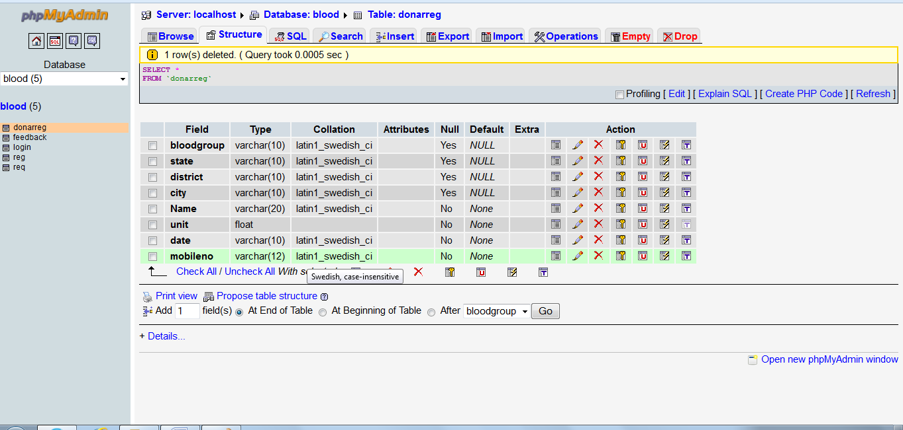

FEED BACK

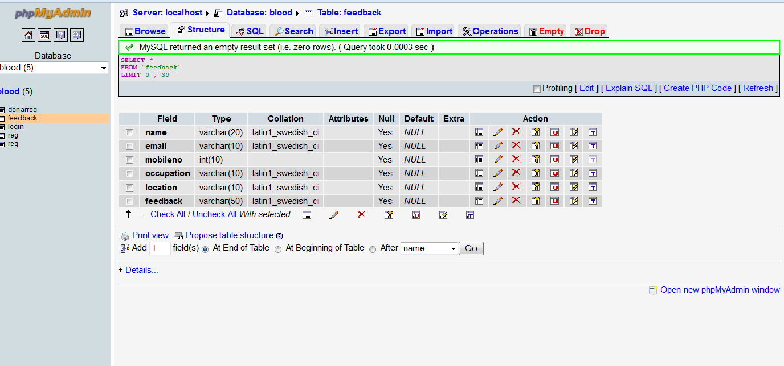

LOGIN

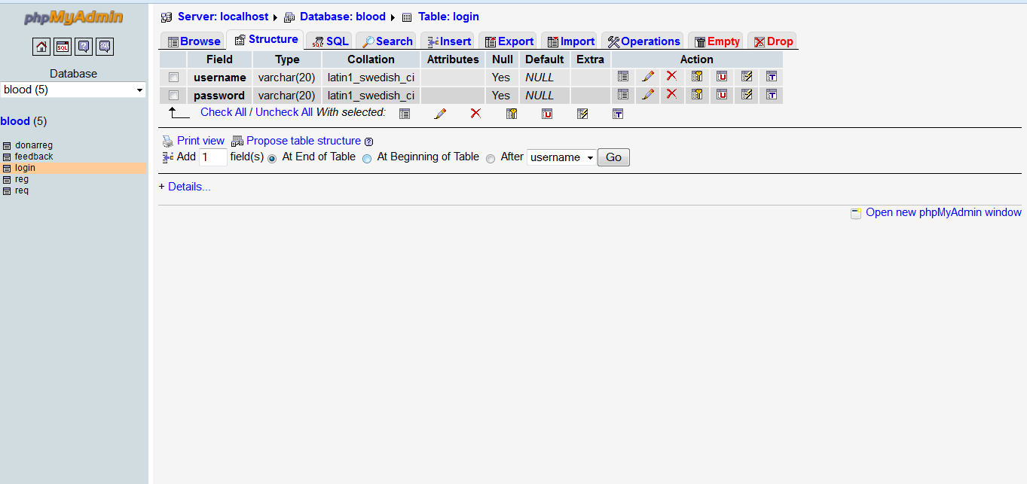

REGISTRATION

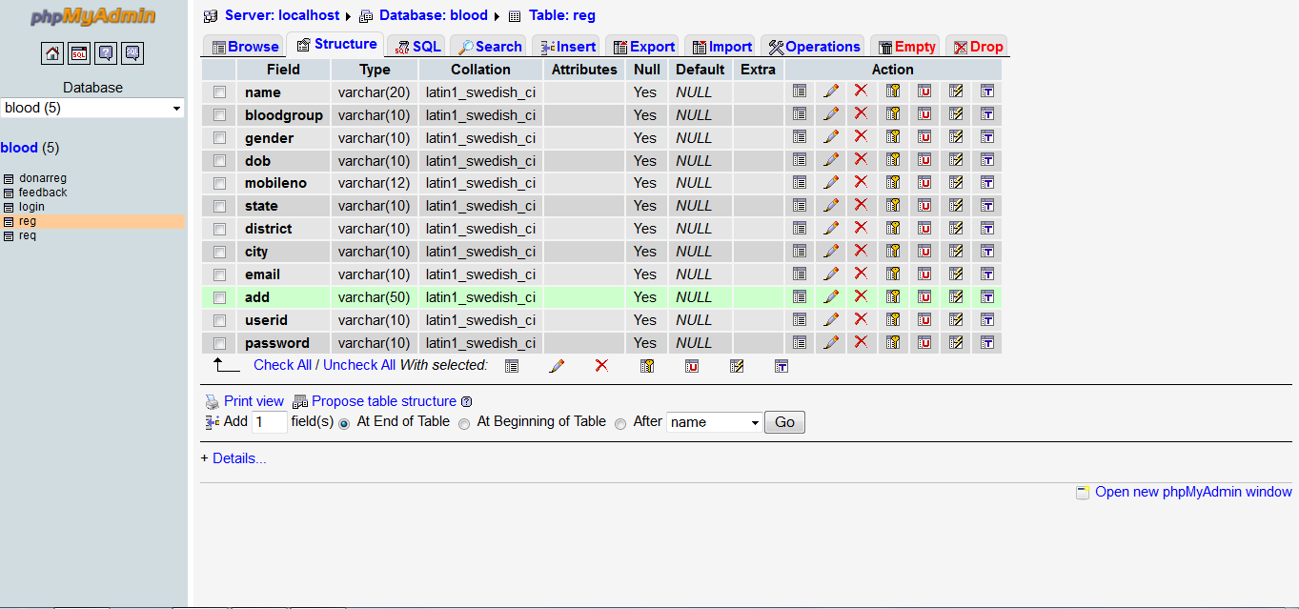

BLOOD REQUESTER

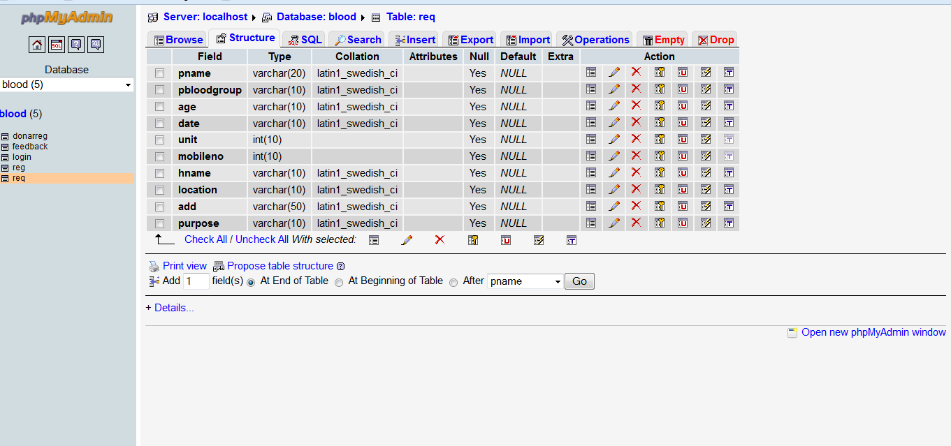

##### 

**Objective:**

The project is intended to provide a better understanding and friendly environment for other users to maintain all records.

**Salient Features:**

1. User Friendly:

Provides a graphical user interface that can be easily navigated to process information and to maintain data of students.

2. Compatible to all windows based system.

3. Easy to understand the working and flow of information.

4. Facility to view User Log, detailed info, student and staff detail, fees generation etc.

5. Provides about information about user who has logged on and other, many more features.

6. Facilities to change student and staff detail and to modify other information’s.

System Development Life Cycle

**&**

**Process Model**

**System Development Life Cycle**

The most basic phases in system development process are:

1) **Analysis**:

In this phase, analysis of various fields such as requirement, existing system, available options etc is made to know better about “what is to be done” and “how it can be done”.

2) **Design**:

In this phase a design of the system to be developed is made depending upon the results of the analysis made in the previous phase.

3) **Coding**:

In this phase the actual implementation of the project is made. System design developed in previous phase is coded to obtain desired system.

4) **Testing**:

In this phase the coded system is tested to check whether it meets the requirements for which it has been developed.

SYSTEM DEVELOPMENT LIFE CYCLE

Testing

Coding

Design

Analysis

**Process Model**

**The ‘Water Fall Model’:**

The Waterfall model offers a means of making the development process more visible.

This model is used when one or more of the following criteria are met:

1. When the detailed requirements are known and are very stable.
2. When the type of application has been developed before.
3. When the type of software class (e.g., compilers or operating systems) has been demonstrated to be appropriate.
4. When the project has a low risk in such areas as getting the wrong interface or not meeting stringent performance requirements.
5. When the project has a high risk in budget and schedule predictability and control.

The principle **stages** of the process are as under.

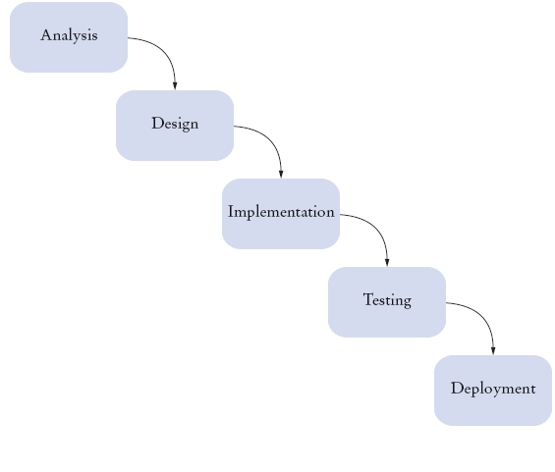

**Requirement Analysis and Definition**:

The system’s services constraints and goals are established by consultation with system users. Both users and development staff then define them in a manner, which is understandable. After the requirement specification and definition is precisely given, the requirements are analyzed and the feasibility of the system in all aspects is also analyzed.

**System and Software design**

This process partitions the requirements to shrink hardware or software systems. Overall system architecture is established in this phase. It involves representing the software system functions in a form that may be transformed into one or more executable programs. The data flow and ultimately how the system execution flows are represented in this phase.

Implementation :

The software design is realized as a set of programs or program units. These programs or program units are implemented and tested. This unit testing involves verifying that each unit meets its specifications. If the outcome is not as per user-requirements or some modifications are needed, then relevant changes are made to the units.

Integration and System Testing:

In this phase the complete system is tested to ensure that the software requirements have been met. After system testing, required modifications are made or if bugs are found they are removed. If no modifications are remaining, the software system will be delivered to the customer.

Operation and Maintenance:

It is, normally, the longest life cycle phase. The system is installed and put into practical use. Maintenance involves correcting errors which were not discovered in earlier stages of the life cycle, improving the implementation of system units and enhancing the system’s services as new requirements are discovered. Here, this phase is not to be carried out by the developers.

Main Platform of the Project

**Introduction**:

This software is developed to make the work of student and staff in any institute scenario, easier and to save time. With the help of this software different user can simply add the appropriate data. This software can perform many work i.e. maintain student information, staff detail, daily attendances, attendance generation and many more. In this software user can perform all the work, which are essential for institute management.

**Minimum System Requirement:**

1. 20 MB of free disk space
2. 32 MB RAM
3. Processor 786 or higher
4. Microsoft Windows TM
5. (95/98/Me/NT4/2000/XP/)
6. 15” Color Monitor
7. 1.44 MB Floppy Drive
8. 16x CD-R Drive
9. Keyboard
10. Mouse
11. *1024 X 768 Resolution

**Software Required:**

PHP

WAMP SRVER

WEBBROWSER

**TESTING**

**AND**

**BIBLIOGRAPHY**

**Testing**

Software testing is a crucial element of software quality assurance & represents the ultimate review of specification, design and code generation.

**White Box testing**

It is also called glass box testing. It is a case design method that uses the control structure of the procedure design to drive cases. Using white box testing method the s/w engineer can drive test cases that are…..

* Guarantee all independent paths within a module have been exercised at least once.
* Exercise or logical decision on their true and false sides
* Exercise all loops at their boundaries & their operational bounds
* Exercise internal data structure to ensure their validity

**Black Box testing**

It is also called behavioral testing and focuses on the functional requirement of the s/w. This means that black box testing enables s/w engineer to drive a set of the input condition that fully exercise all functional requirement for program. Black box testing is used for answering the following question:

* How is functional validity tested?
* How is system behavior and performance?
* What class of input will make good test cases?
* Is system particularly sensitive to certain input values?
* How are the boundaries of data class isolated?
* What data rate and data volume system can tolerate?
* What effect will specific combination of data have on system operation?

CODDING

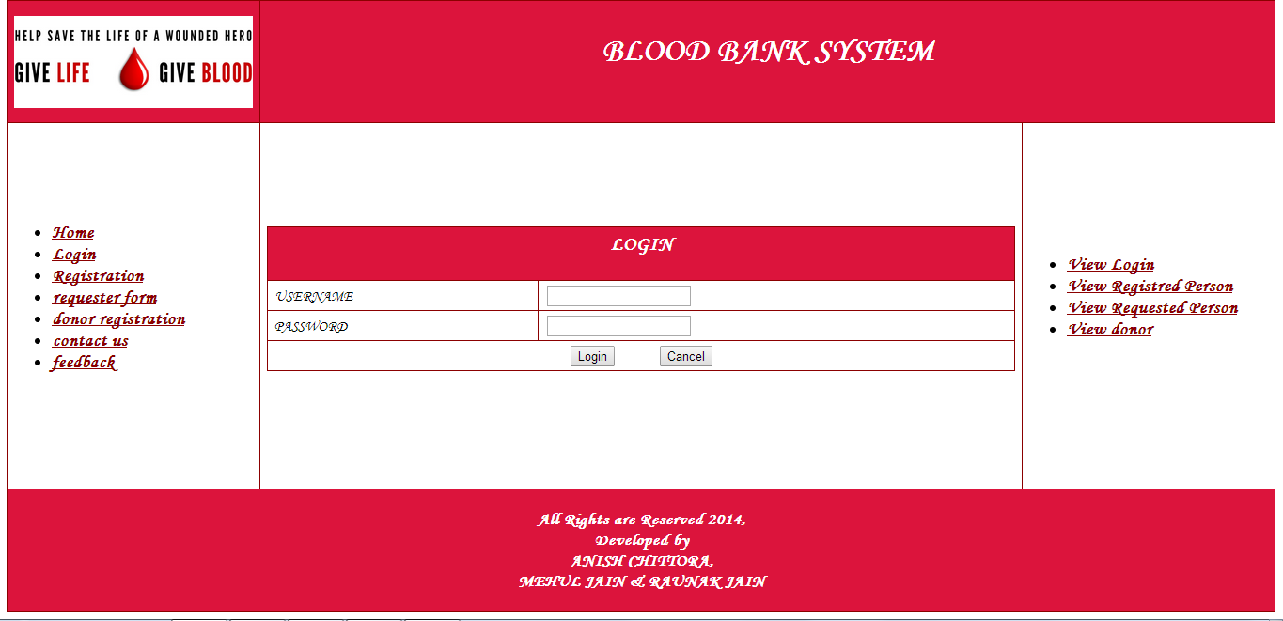

<?php

include("header.inc1.php");

?>

<script>

function validate()

{

var u=document.loginfrm.usrtxt.value;

var p=document.loginfrm.passtxt.value;

if(u=="")

{

alert("Please Enter the Username");

return false;

}

if(p=="")

{

alert("Please Enter the Password");

return false;

}

return true;

}

</script>

<form name="loginfrm" action="home.php" method="post">

<table id="customers">

<tr>

<th colspan="2"><center><h3>LOGIN</h1></center></th>

</tr>

</tr>

<tr><td>USERNAME</td><td><input type="text" class="a" name="usrtxt" value=""/></td></tr>

<tr><td>PASSWORD</td><td><input type="password" name="passtxt" value=""/></td></tr><tr align="center"><td colspan="2"><input type="submit" value="Login" onclick="validate()"/>&nbsp &nbsp &nbsp&nbsp&nbsp&nbsp&nbsp&nbsp&nbsp<input type="reset" value="Cancel"/></td></tr>

</table>

</form>

<?php

include("footer.inc.php");

?>

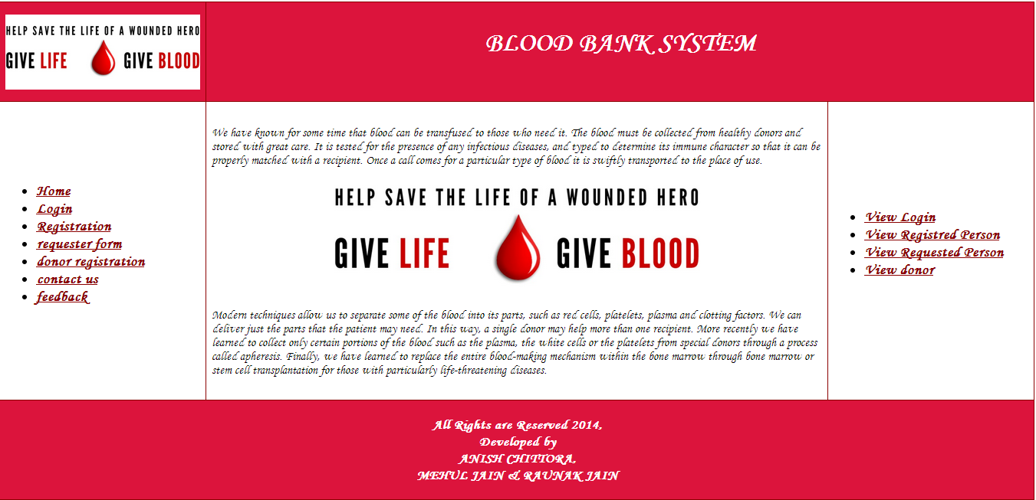

<?php

include("header.inc1.php");

?>

We have known for some time that blood can be transfused to those who need it. The blood must be collected from healthy donors and stored with great care. It is tested for the presence of any infectious diseases, and typed to determine its immune character so that it can be properly matched with a recipient. Once a call comes for a particular type of blood it is swiftly transported to the place of use.

<center><img src="image/head.jpg" width="60%"/></center>

Modern techniques allow us to separate some of the blood into its parts, such as red cells, platelets, plasma and clotting factors. We can deliver just the parts that the patient may need. In this way, a single donor may help more than one recipient. More recently we have learned to collect only certain portions of the blood such as the plasma, the white cells or the platelets from special donors through a process called apheresis. Finally, we have learned to replace the entire blood-making mechanism within the bone marrow through bone marrow or stem cell transplantation for those with particularly life-threatening diseases.

<?php

include("footer.inc.php");

?>

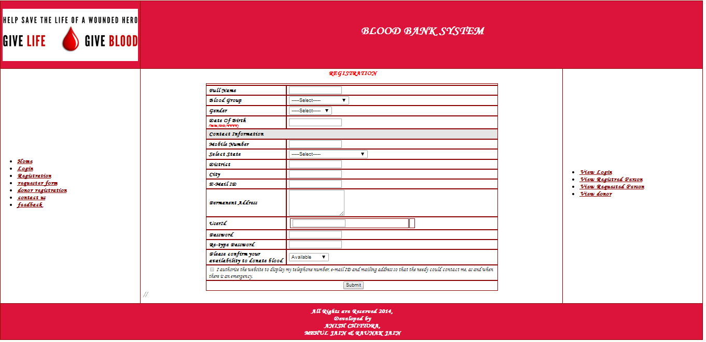

<?php

include("header.inc.php");

?>

<script>

function validate()

{

var p=document.regfrm.txtFullName.value;

var q=document.regfrm.dpBloodGroup.value;

var r=document.regfrm.txtAge.value;

var s=document.regfrm.txtWhenYouNeedDate.value;

var t=document.regfrm.txtHowManyUnits.value;

var u=document.regfrm.txtMobileNumber.value;

var w=document.regfrm.txtLandLineNumber.value;

var x=document.regfrm.txtHospitalName.value;

var y=document.regfrm.txtLocation.value;

var z=document.regfrm.txtPatientAddress.value;

var a=document.regfrm.txtPurpose.value;

if(p=="")

{

alert("Please Enter your first Name");

return false;

}

if(q=="")

{

alert("Please Select Blood Group");

return false;

}

if(r=="")

{

alert("Please enter date of birth");

return false;

}

if(s=="")

{

alert("Please enter date when u need blood");

return false;

}

if(t=="")

{

alert("Please Enter how many units u want");

return false;

}

if(u=="")

{

alert("Please enter mobile number");

return false;

}

if(v=="")

{

alert("Please enter land line number");

return false;

}

if(w=="")

{

alert("Please enter Hospital name");

return false;

}

if(y=="")

{

alert("Please Enter the location");

return false;

}

if(z=="")

{

alert("Please enter the address");

return false;

}

if(a=="")

{

alert("Please enter the Purpose");

return false;

}

return true;

}

</script>

<style type="text/css">

.waitingdiv

{

background-color: #F5F8FA;

border: 1px solid #5A768E;

color: #333333;

font-size: 93%;

margin-bottom: 1em;

margin-top: 0.2em;

padding: 8px 12px;

width: 8.4em;

}

/*.ui-datepicker

{

font-size: 8pt !important;

}*/

.style1 {

color: #CC0000;

font-weight: bold;

}

</style>

<form name="regfrm" action="rsave.php" method="post">

<center><h3><font color="red">REGISTRATION</font></h3></center>

<table cellspacing="1" cellpadding="3" width="70%" align="center">

<tbody><tr>

<td colspan="3" align="center">

</td>

</tr>

<tr>

<td width="107" style="width: 115px">

<strong>Full Name</strong>

</td>

<td width="307" style="width: 327px">

<input name="txtFullName" type="text" maxlength="100" id="txtFullName" class="textarea">

</td>

</tr>

<tr bgcolor="#ffffff">

<td style="width: 107px">

<strong>Blood Group</strong>

</td>

<td style="width: 327px">

<select name="dpBloodGroup" id="dpBloodGroup" class="textarea">

<option value="Select">-----Select-----</option>

<option value="A+">A+</option>

<option value="A-">A-</option>

<option value="B+">B+</option>

<option value="B-">B-</option>

<option value="AB+">AB+</option>

<option value="AB-">AB-</option>

<option value="O+">O+</option>

<option value="O-">O-</option>

<option value="A1+">A1+</option>

<option value="A1-">A1-</option>

<option value="A2+">A2+</option>

<option value="A2-">A2-</option>

<option value="A1B+">A1B+</option>

<option value="A1B-">A1B-</option>

<option value="A2B+">A2B+</option>

<option value="A2B-">A2B-</option>

<option value="Bombay Blood Group">Bombay Blood Group</option>

</select>

</td>

</tr>

<tr>

<td style="width: 107px">

<strong>Gender</strong>

</td>

<td style="width: 327px">

<select name="dpGender" id="dpGender" class="textarea">

<option value="0">-----Select-----</option>

<option value="M">Male</option>

<option value="F">Female</option>

</select>

</td>

</tr>

<tr bgcolor="#ffffff">

<td style="width: 107px">

<strong>Date Of Birth<br>

<font color="#ff0000" size="1">(MM/DD/YYYY)</font> </strong>

</td>

<td style="width: 327px">

<input name="txtDOB" type="text" maxlength="10" id="txtDOB" class="textarea" onchange="javascript:return enterDateFormat(&#39;txtDOB&#39;)">

</td>

</tr>

<tr bgcolor="#e5e5e5">

<td height="30" colspan="3">

<strong>Contact Information</strong>

</td>

</tr>

<tr bgcolor="#ffffff">

<td style="width: 107px">

<strong>Mobile Number<br>

</td>

<td style="width: 327px">

<input name="txtMobileNumber" type="text" maxlength="10" id="txtMobileNumber" class="textarea" onkeypress="javascript:return allowOnlyNumbers(event);">

</td>

</tr>

<tr>

<td style="width: 107px">

<strong>Select State</strong>

</td>

<td style="width: 327px">

<select name="dpState" id="dpState" class="textarea">

<option value="">-----Select-----</option><option value="Andaman and Nicobar Islands"> Andaman and Nicobar Islands</option><option value="Andhra Pradesh">Andhra Pradesh</option><option value="Arunachal

Pradesh">Arunachal

Pradesh </option><option value="Assam">Assam </option><option value="Bihar">Bihar </option><option value="Chandigarh ">Chandigarh </option><option value="Chhattisgarh">Chhattisgarh </option><option value="Dadra and Nagar

Haveli">Dadra and Nagar

Haveli </option><option value="Daman and Diu">Daman and Diu

</option><option value="Delhi">Delhi </option><option value="Goa">Goa </option><option value="Gujrat">Gujarat </option><option value="Haryana">Haryana </option><option value="Himachal Pradesh">Himachal Pradesh

</option><option value="Jammu and Kashmir">Jammu and Kashmir </option><option value="Jharkhand">Jharkhand </option><option value="Karnataka ">Karnataka </option><option value="Kerala">Kerala </option><option value="Lakshadweep ">Lakshadweep </option><option value="Madhya Pradesh">Madhya Pradesh

</option><option value="Maharashtra">Maharashtra </option><option value="Manipur">Manipur </option><option value="Meghalaya">Meghalaya </option><option value="Mizoram">Mizoram </option><option value="Nagaland">Nagaland </option><option value="Odisha">Odisha</option><option value="Pondicherry">Pondicherry</option><option value="Punjab">Punjab </option><option value="Rajasthan">Rajasthan </option><option value="Sikkim">Sikkim </option><option value="Tamil Nadu">Tamil Nadu </option><option value="Tripura">Tripura </option><option value="Uttar Pradesh">Uttar Pradesh

</option><option value="Uttaranchal">Uttaranchal </option><option value="West Bengal">West Bengal</option></select>

<input type="hidden" name="StateCascading_ClientState" id="StateCascading_ClientState" value="::::::">

</td>

</tr>

<tr>

<td style="width: 107px">

<strong>District</strong>

</td>

<td>

<input type="text" name="district" >

</td>

</tr>

<tr>

<td style="width: 107px">

<strong>City</strong>

</td>

<td>

<input type="text" name="city" >

</td>

</tr>

</div>

</td>

</tr>

<tr bgcolor="#ffffff">

<td style="width: 107px">

<strong>E-Mail ID</strong>

</td>

<td style="width: 327px">

<input name="txtEmailId" type="text" maxlength="100" id="txtEmailId" class="textarea">

</td>

</tr>

<tr bgcolor="#ffffff">

<td style="width: 107px">

<strong>Permanent Address</strong>

</td>

<td style="width: 327px">

<textarea name="txtPermentAddress" rows="2" cols="20" id="txtPermentAddress" class="textarea" style="height:76px;width:160px;"></textarea>

</td>

</tr>

<tr>

<td style="width: 107px">

<strong>UserId</strong>

</td>

<td style="width: 327px">

<div>

<div id="PnlUsrDetails">

<table>

<tbody><tr>

<td style="width: 327px">

<input name="txtUserName" type="text" maxlength="100" onchange="javascript:setTimeout(&#39;__doPostBack(\&#39;txtUserName\&#39;,\&#39;\&#39;)&#39;, 0)" onkeypress="if (WebForm_TextBoxKeyHandler(event) == false) return false;return IsAlphaNumeric(event);" id="txtUserName" ondrop="return false;" onpaste="return false;">

<span id="error" style="color: Red; display: none">* Special Characters not allowed, Please use only letters (a-z) and numbers</span>

<div class="waitingdiv" id="loadingdiv" style="display: none; margin-left: 5.3em">

<img src="./registraion form_files/LoadingImage.gif" alt="Loading">Please wait...

</div>

</td>

<td>

</td>

</tr>

</tbody></table>

</div>

</div>

</td>

</tr>

<tr id="trPassword">

<td style="width: 107px">

<strong>Password</strong>

</td>

<td style="width: 327px">

<input name="txtUserPassword" type="password" maxlength="50" id="txtUserPassword" class="textarea">

</td>

</tr>

<tr id="trRetypePassword">

<td style="width: 107px">

<strong>Re-type Password</strong>

</td>

<td style="width: 327px">

<input name="txtRetypePassword" type="password" maxlength="50" id="txtRetypePassword" class="textarea">

</td>

</tr>

<tr>

<td style="width: 107px">

<strong>Please confirm your availability to donate blood</strong>

</td>

<td style="width: 327px">

<select name="dpAvailUnAvailable" id="dpAvailUnAvailable">

<option selected="selected" value="A">Available</option>

<option value="U">UnAvailable</option>

</select>

</td>

</tr>

<tr>

<td colspan="2" style="width: 107px" valign="top" height="30">

<input type="checkbox" id="chkTermsAndCondition" name="chkTermsAndCondition">

I authorise the website to display my telephone number, e-mail ID and mailing address

so that the needy could contact me, as and when there is an emergency.

</td>

</tr>

<tr bgcolor="#ffffff">

<td colspan="3" height="30">

<div align="center">

&nbsp;

<input type="submit" name="btnSubmit" value="Submit" ">

</div>

</td>

</tr>

</tbody></table>

<?php<script type="text/javascript">

//<![CDATA[

(function() {var fn = function() {$get("ToolkitScriptManager1_HiddenField").value = '';Sys.Application.remove_init(fn);};Sys.Application.add_init(fn);})();

theForm.oldSubmit = theForm.submit;

theForm.submit = WebForm_SaveScrollPositionSubmit;

theForm.oldOnSubmit = theForm.onsubmit;

theForm.onsubmit = WebForm_SaveScrollPositionOnSubmit;

Sys.Application.add_init(function() {

$create(Sys.Extended.UI.CalendarBehavior, {"button":$get("Image1"),"format":"MM/dd/yyyy","id":"ctl07"}, null, null, $get("txtDOB"));

});

Sys.Application.add_init(function() {

$create(Sys.Extended.UI.CascadingDropDownBehavior, {"Category":"State","ClientStateFieldID":"StateCascading_ClientState","LoadingText":"Loading State...","PromptText":"-----Select-----","ServiceMethod":"BindStatedropdown","ServicePath":"../../DropdownWebService.asmx","id":"StateCascading"}, null, null, $get("dpState"));

});

Sys.Application.add_init(function() {

$create(Sys.Extended.UI.CascadingDropDownBehavior, {"Category":"District","ClientStateFieldID":"DistrictCascading_ClientState","LoadingText":"Loading District...","ParentControlID":"dpState","PromptText":"-----Select-----","ServiceMethod":"BindDistrictdropdown","ServicePath":"../../DropdownWebService.asmx","id":"DistrictCascading"}, null, null, $get("dpDistrict"));

});

Sys.Application.add_init(function() {

$create(Sys.Extended.UI.CascadingDropDownBehavior, {"Category":"City","ClientStateFieldID":"CityCascading_ClientState","LoadingText":"Loading Cities...","ParentControlID":"dpDistrict","PromptText":"-----Select-----","ServiceMethod":"BindCitydropdown","ServicePath":"../../DropdownWebService.asmx","id":"CityCascading"}, null, null, $get("dpCity"));

});

//]]>

</script>

<?php

include("footer.inc.php");

?>

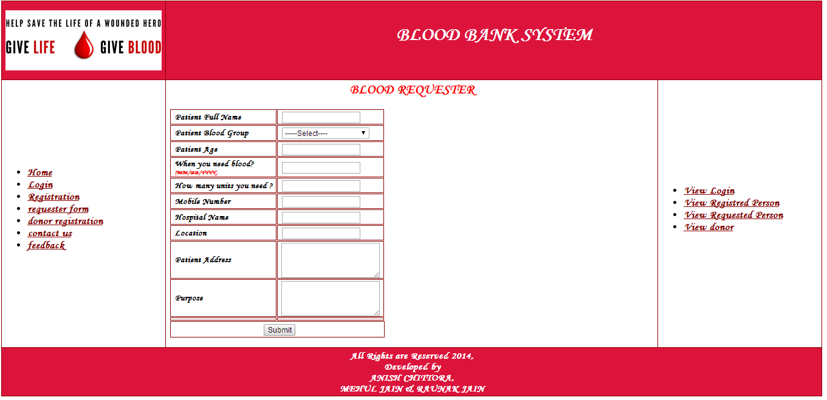

<?php

include("header.inc.php");

?>

<script>

function validate()

{

var p=document.reqfrm.txtPatientName.value;

var q=document.reqfrm.dpBloodGroup.value;

var r=document.reqfrm.txtAge.value;

var s=document.reqfrm.txtWhenYouNeedDate.value;

var t=document.reqfrm.txtHowManyUnits.value;

var u=document.reqfrm.txtMobileNumber.value;

var w=document.reqfrm.txtLandLineNumber.value;

var x=document.reqfrm.txtHospitalName.value;

var y=document.reqfrm.txtLocation.value;

var z=document.reqfrm.txtPatientAddress.value;

var a=document.reqfrm.txtPurpose.value;

if(p=="")

{

alert("Please Enter the Patient Name");

return false;

}

if(q=="")

{

alert("Please Select Blood Group");

return false;

}

if(r=="")

{

alert("Please enter date of birth");

return false;

}

if(s=="")

{

alert("Please enter date when u need blood");

return false;

}

if(t=="")

{

alert("Please Enter how many units u want");

return false;

}

if(u=="")

{

alert("Please enter mobile number");

return false;

}

if(v=="")

{

alert("Please enter land line number");

return false;

}

if(w=="")

{

alert("Please enter Hospital name");

return false;

}

if(y=="")

{

alert("Please Enter the location");

return false;

}

if(z=="")

{

alert("Please enter the address");

return false;

}

if(a=="")

{

alert("Please enter the Purpose");

return false;

}

return true;

}

</script>

<form name="reqfrm" action="reuestsave.php" method="post">

<table>

<tbody>

<h2><font color="red" ><center>BLOOD REQUESTER</center></font></h2>

<tr bgcolor="#ffffff">

<td>

<strong>Patient Full Name</strong>

</td>

<td>

<input name="txtPatientName" type="text" maxlength="100" id="txtPatientName" class="textarea" onkeydown="javascript:return enterSubmit(&#39;btnSubmit&#39;);">

</td>

</tr>

<tr bgcolor="#ffffff">

<td>

<strong>Patient Blood Group</strong>

</td>

<td>

<select name="dpBloodGroup" id="dpBloodGroup" onkeydown="javascript:return enterSubmit(&#39;btnSubmit&#39;);">

<option value="Select">-----Select----</option>

<option value="A+">A+</option>

<option value="A-">A-</option>

<option value="B+">B+</option>

<option value="B-">B-</option>

<option value="AB+">AB+</option>

<option value="AB-">AB-</option>

<option value="O+">O+</option>

<option value="O-">O-</option>

<option value="A1+">A1+</option>

<option value="A1-">A1-</option>

<option value="A2+">A2+</option>

<option value="A2-">A2-</option>

<option value="A1B+">A1B+</option>

<option value="A1B-">A1B-</option>

<option value="A2B+">A2B+</option>

<option value="A2B-">A2B-</option>

<option value="Bombay Blood Group">Bombay Blood Group</option>

</select>

</td>

</tr>

<tr bgcolor="#ffffff">

<td>

<strong>Patient Age</strong>

</td>

<td>

<input name="txtAge" type="text" maxlength="3" id="txtAge" class="textarea" onkeypress="javascript:return allowOnlyNumbers(event);" onkeydown="javascript:return enterSubmit(&#39;btnSubmit&#39;);">

</td>

</tr>

<tr bgcolor="#ffffff">

<td>

<strong>When you need blood?<br>

<font color="#ff0000" size="1">(MM/DD/YYYY)</font></strong>

</td>

<td>

<input name="txtWhenYouNeedDate" type="text" maxlength="10" id="txtWhenYouNeedDate" class="textarea" onchange="javascript:return enterDateFormat(&#39;txtWhenYouNeedDate&#39;)" onkeydown="javascript:return enterSubmit(&#39;btnSubmit&#39;);">

</td>

</tr>

<tr>

<td>

<strong>How many units you need&nbsp;?</strong>

</td>

<td>

<input name="txtHowManyUnits" type="text" maxlength="2" id="txtHowManyUnits" class="textarea" onkeypress="javascript:return allowOnlyNumbers(event);" onkeydown="javascript:return enterSubmit(&#39;btnSubmit&#39;);">

</td>

</tr>

<tr>

<td>

<strong>Mobile Number<br>

</td>

<td>

<input name="txtMobileNumber" type="text" maxlength="10" id="txtMobileNumber" class="textarea" onkeypress="javascript:return allowOnlyNumbers(event);" onkeydown="javascript:return enterSubmit(&#39;btnSubmit&#39;);">

</td>

</tr>

<tr>

<td>

<strong>Hospital Name</strong>

</td>

<td>

<input name="txtHospitalName" type="text" maxlength="100" id="txtHospitalName" class="textarea" onkeydown="javascript:return enterSubmit(&#39;btnSubmit&#39;);">

</td>

</tr>

<tr>

<td>

<strong>Location</strong>

</td>

<td>

<input name="txtLocation" type="text" maxlength="100" id="txtLocation" class="textarea" onkeydown="javascript:return enterSubmit(&#39;btnSubmit&#39;);">

</td>

</tr>

<tr>

<td>

<strong>Patient Address</strong>

</td>

<td>

<textarea name="txtPatientAddress" rows="2" cols="20" id="txtPatientAddress" class="textarea" onkeypress="javascript:return fnlength(this,&#39;Please enter text less than 500&#39;);" onchange="javascript:return fnlength(this,&#39;Please enter text less than 500&#39;);" onkeydown="javascript:return enterSubmit(&#39;btnSubmit&#39;);" style="height:64px;width:180px;"></textarea>

</td>

</tr>

<tr>

<td>

<strong>Purpose</strong>

</td>

<td>

<textarea name="txtPurpose" rows="2" cols="20" id="txtPurpose" class="textarea" onkeypress="javascript:return fnlength(this,&#39;Please enter text less than 500&#39;);" onchange="javascript:return fnlength(this,&#39;Please enter text less than 500&#39;);" onkeydown="javascript:return enterSubmit(&#39;btnSubmit&#39;);" style="height:64px;width:180px;"></textarea>

</td>

</tr>

<tr>

<td>

<input name="hdnPostYourBloodRequestID" type="hidden" id="hdnPostYourBloodRequestID">

</td>

</td>

<td>

</td>

</tr>

<tr bgcolor="#ffffff">

<td colspan="3" height="30">

<div align="center">

&nbsp;

<input type="submit" name="btnSubmit" value="Submit" onclick="validate()" id="btnSubmit" class="textarea"></div>

</td>

</tr>

</tbody></table>

</form>

<?php

include("footer.inc.php");

?>

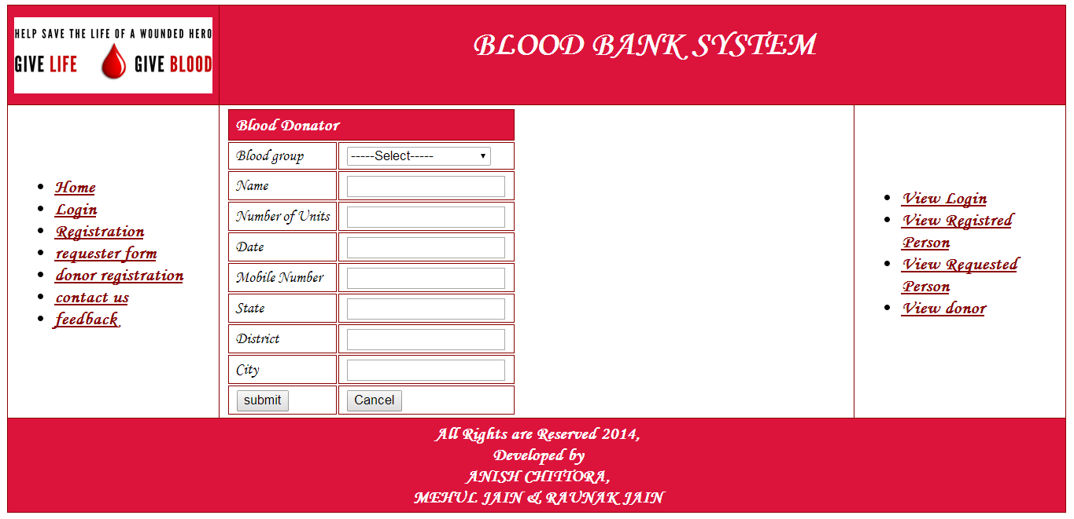

<?php

include("header.inc.php");

?>

<table cellspacing="0" cellpadding="5" width="257" border="0" align="center">

<tbody>

<form name="donar" action="dsave.php" method="post">

<table>

<tr><th colspan="2">Blood Donator</th></tr>

<tr>

<td>Blood group</td><td><select name="dpBloodGroup" id="dpBloodGroup" class="textarea">

<option value="Select">-----Select-----</option>

<option value="A+">A+</option>

<option value="A-">A-</option>

<option value="B+">B+</option>

<option value="B-">B-</option>

<option value="AB+">AB+</option>

<option value="AB-">AB-</option>

<option value="O+">O+</option>

<option value="O-">O-</option>

<option value="A1+">A1+</option>

<option value="A1-">A1-</option>

<option value="A2+">A2+</option>

<option value="A2-">A2-</option>

<option value="A1B+">A1B+</option>

<option value="A1B-">A1B-</option>

<option value="A2B+">A2B+</option>

<option value="A2B-">A2B-</option>

<option value="Bombay Blood Group">Bombay Blood Group</option>

</select></td>

</tr>

<tr>

<td>Name</td><td><input type="text" name="dname"></td>

</tr>

<tr>

<td>Number of Units</td><td><input type="text" name="unit"></td>

</tr>

<tr>

<td>Date</td><td><input type="text" name="dt"></td>

</tr>

<tr>

<td>Mobile Number</td><td><input type="text" name="mnum"></td>

</tr>

<tr>

<td>State</td><td><input type="text" name="state"></td>

</tr>

<tr>

<td>District</td><td><input type="text" name="dist"></td>

</tr>

<tr>

<td>City</td><td><input type="text" name="city"></td>

</tr>

<tr>

<td><input type="submit" value="submit"/></td><td><input type="reset" value="Cancel"/></td>

</tr>

</table>

</form>

<?php

include("footer.inc.php");

?>

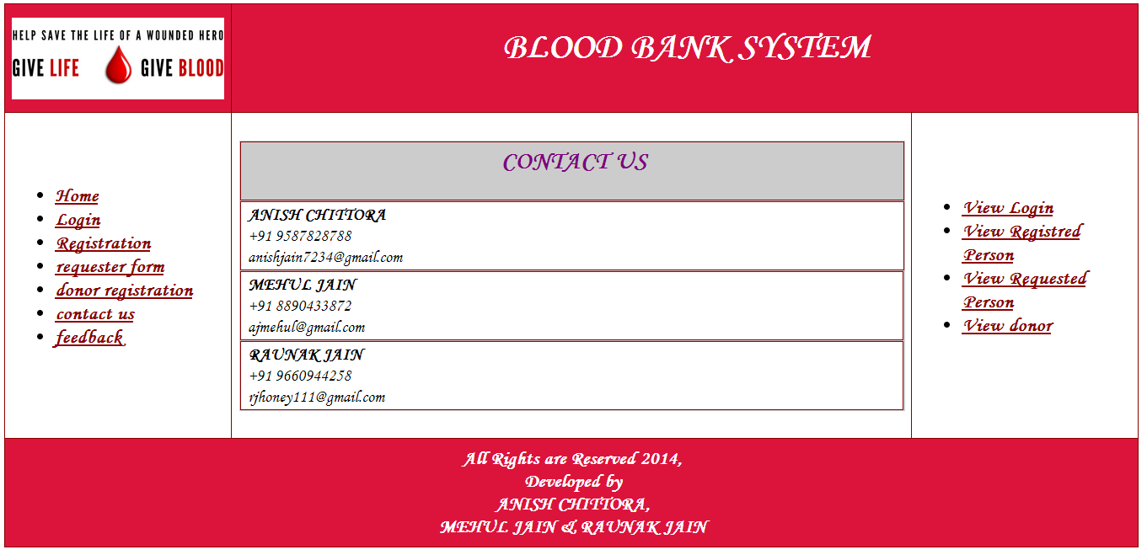

<?php

include("header.inc1.php");

?>

<table bgcolor="#CCCCCC" cellpadding="5" cellspacing="1" width="100%">

<tr><td colspan="2"><center><h2><font color="purple">CONTACT US</font></h2>

</center></td></tr>

<tr>

<td bgcolor="#FFFFFF" colspan="2"><strong>ANISH CHITTORA</strong><br>+91 9587828788<br>anishjain7234@gmail.com</td></tr>

<tr><td bgcolor="#FFFFFF"><strong>MEHUL JAIN</strong><br> +91 8890433872<br>ajmehul@gmail.com<br>

</td>

</tr>

<tr>

<td bgcolor="#FFFFFF"><strong>RAUNAK JAIN</strong><br> +91 9660944258<br>rjhoney111@gmail.com</td>

</tr>

</table>

<?php

include("footer.inc.php");

?>

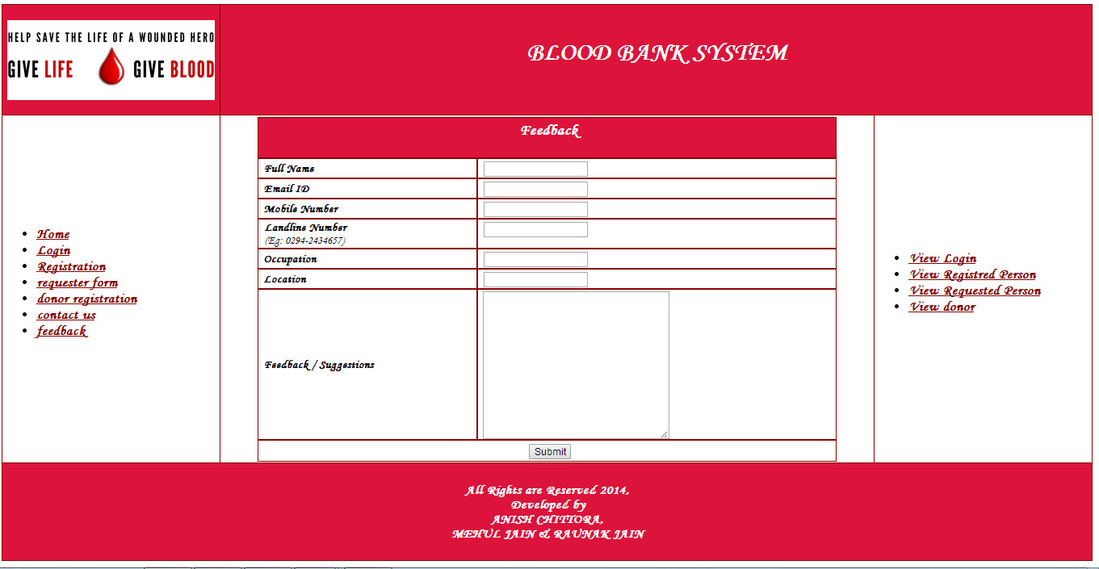

<?php

include("header.inc.php");

?>

<table align="center" cellpadding="3" cellspacing="1" width="90%">

<tbody>

<tr><th colspan="2"><center><h3>Feedback</h3></center></th></tr>

<tr bgcolor="#ffffff">

<td><strong>Full Name</strong></td>

</td>

<td><input name="txtFullName" maxlength="100" id="txtFullName" class="textarea" type="text"></td>

</tr>

<tr bgcolor="#ffffff">

<td><strong>Email ID</strong></td>

</td>

<td><input name="txtEmailId" maxlength="100" id="txtEmailId" class="textarea" type="text"></td>

</tr>

<tr>

<td><strong>Mobile Number</strong></td>

</td>

<td><input name="txtMobileNumber" maxlength="15" id="txtMobileNumber" class="textarea" onkeypress="javascript:return allowOnlyNumbers(event);" type="text"></td>

</tr>

<tr>

<td>

<p><strong>Landline Number<br>

</strong>(Eg: 0294-2434657)</p>

</td>

</td>

<td valign="top"><input name="txtLandLineNumber" maxlength="20" id="txtLandLineNumber" class="textarea" type="text"></td>

</tr>

<tr bgcolor="#ffffff">

<td><strong>Occupation</strong></td>

</td>

<td><input name="txtOccupation" maxlength="100" id="txtOccupation" class="textarea" type="text"></td>

</tr>

<tr bgcolor="#ffffff">

<td><strong>Location</strong></td>

</td>

<td><input name="txtPresentLocation" maxlength="100" id="txtPresentLocation" class="textarea" type="text"></td>

</tr>

<tr bgcolor="#ffffff">

<td><strong>Feedback / Suggestions</strong></td>

</td>

<td><textarea name="txtFeedBack" rows="2" cols="20" id="txtFeedBack" class="textarea" style="height:203px;width:256px;"></textarea></td>

</tr>

<tr bgcolor="#ffffff">

<td colspan="3" height="30">

<div align="center">&nbsp;

<input name="btnSubmit" value="Submit" onclick="javascript:return validation1();" id="btnSubmit" class="textarea" type="submit"></div>

</td>

</tr>

</tbody></table>

<?php

include("footer.inc.php");

?>